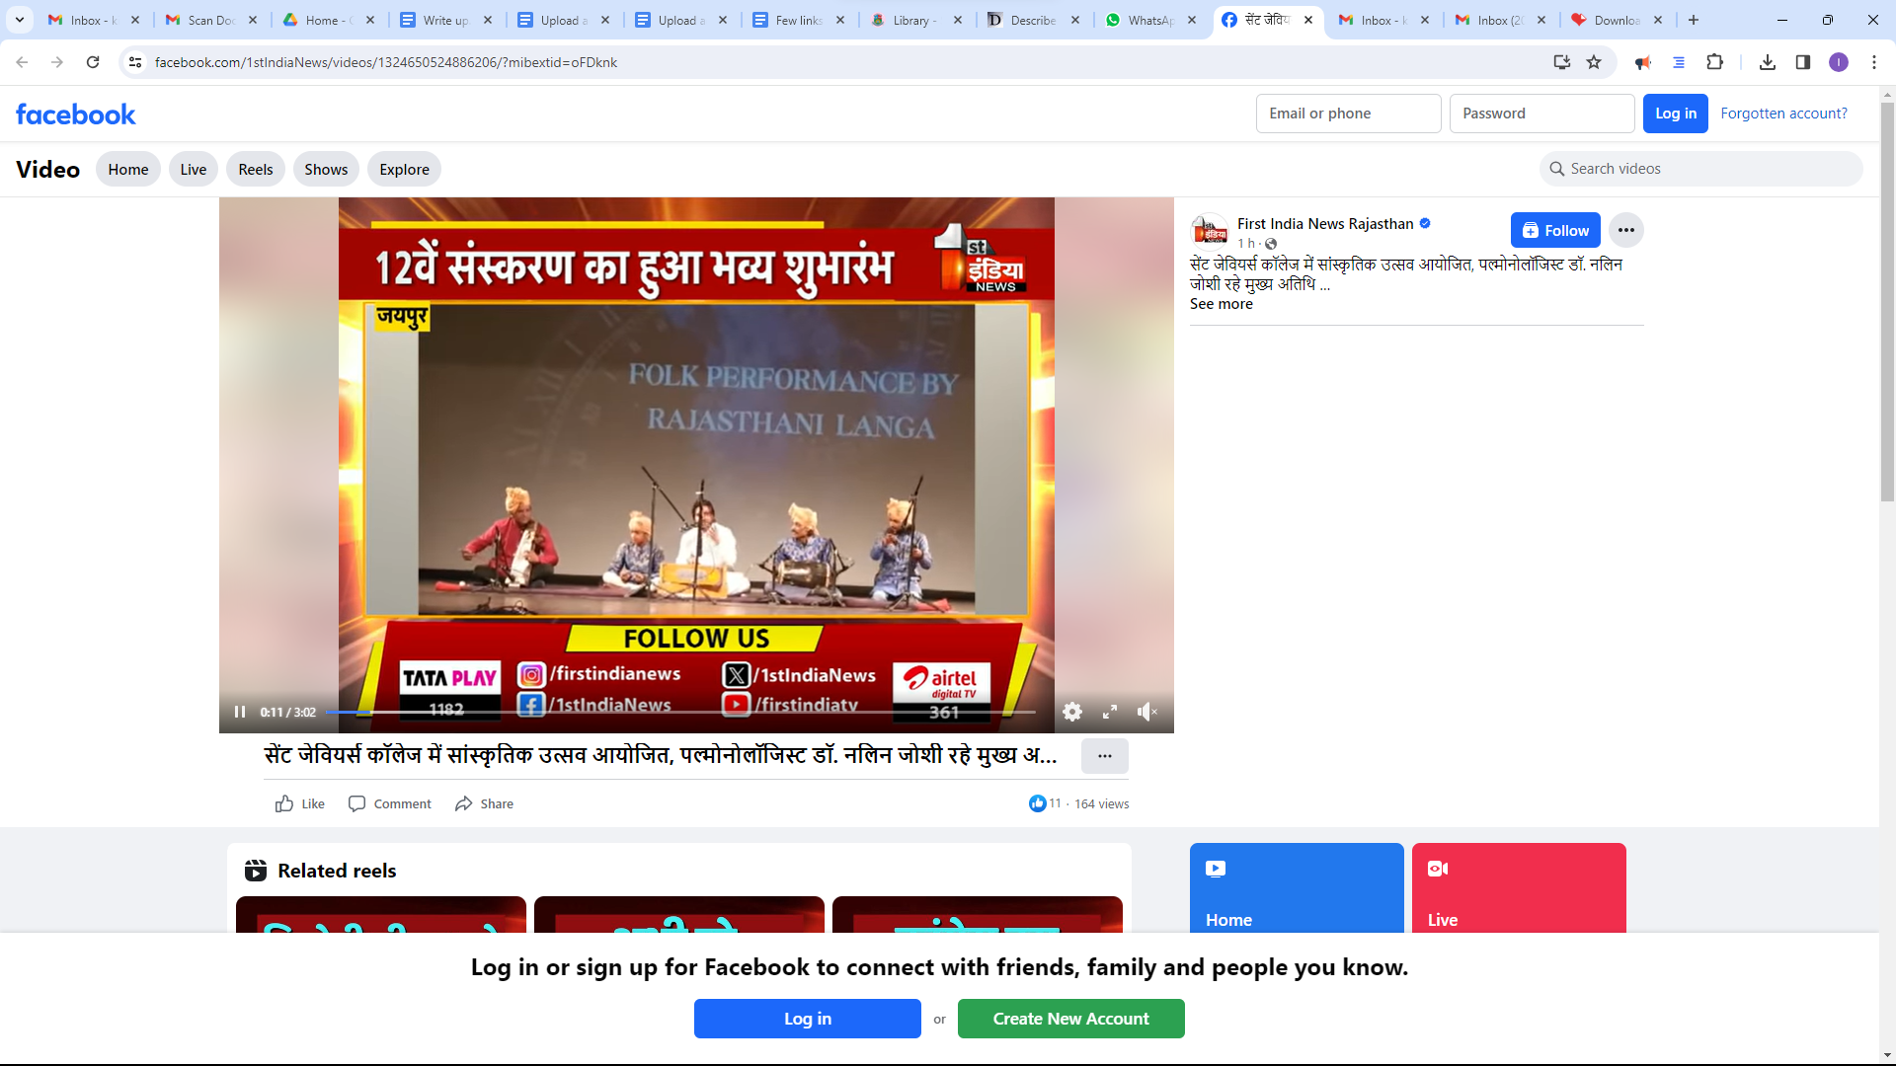
https://www.facebook.com/share/v/pTdeVzypSAY3qAYo/?mibextid=oFDknk

