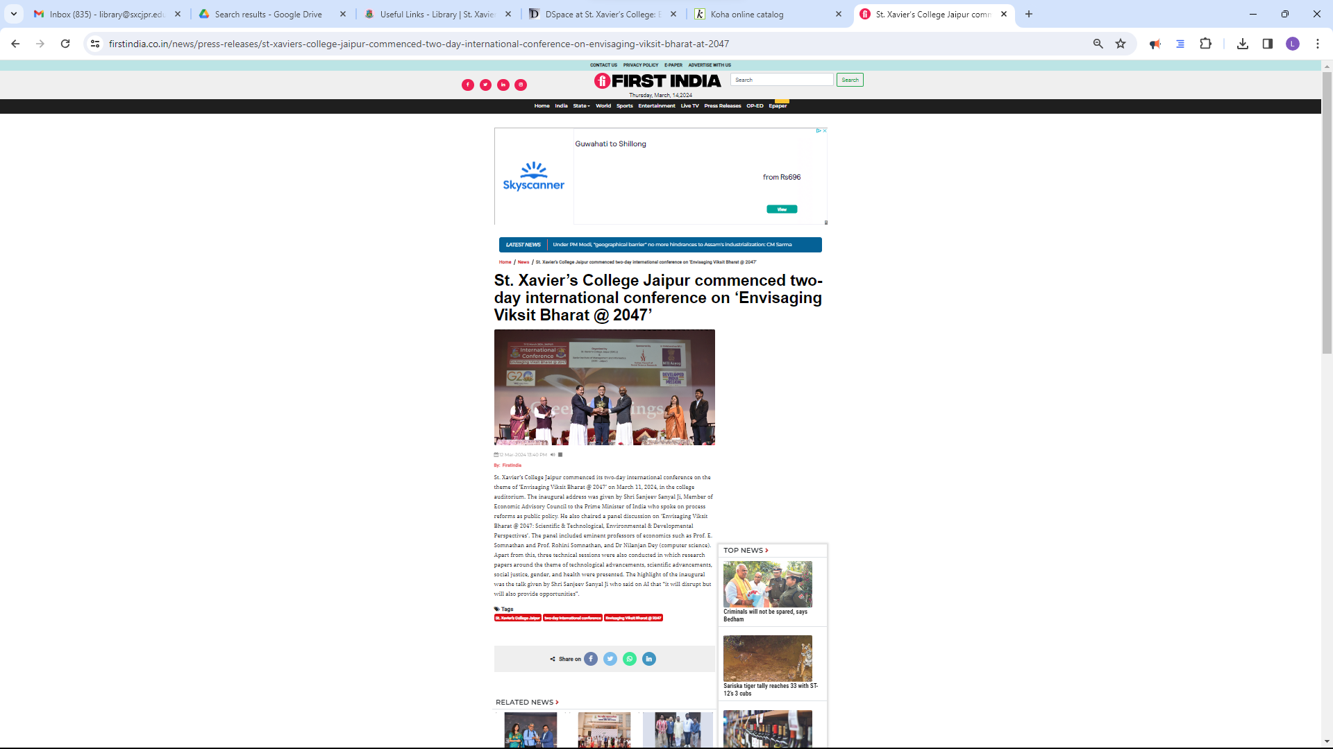

<https://firstindia.co.in/news/press-releases/st-xaviers-college-jaipur-commenced-two-day-international-conference-on-envisaging-viksit-bharat-at-2047>